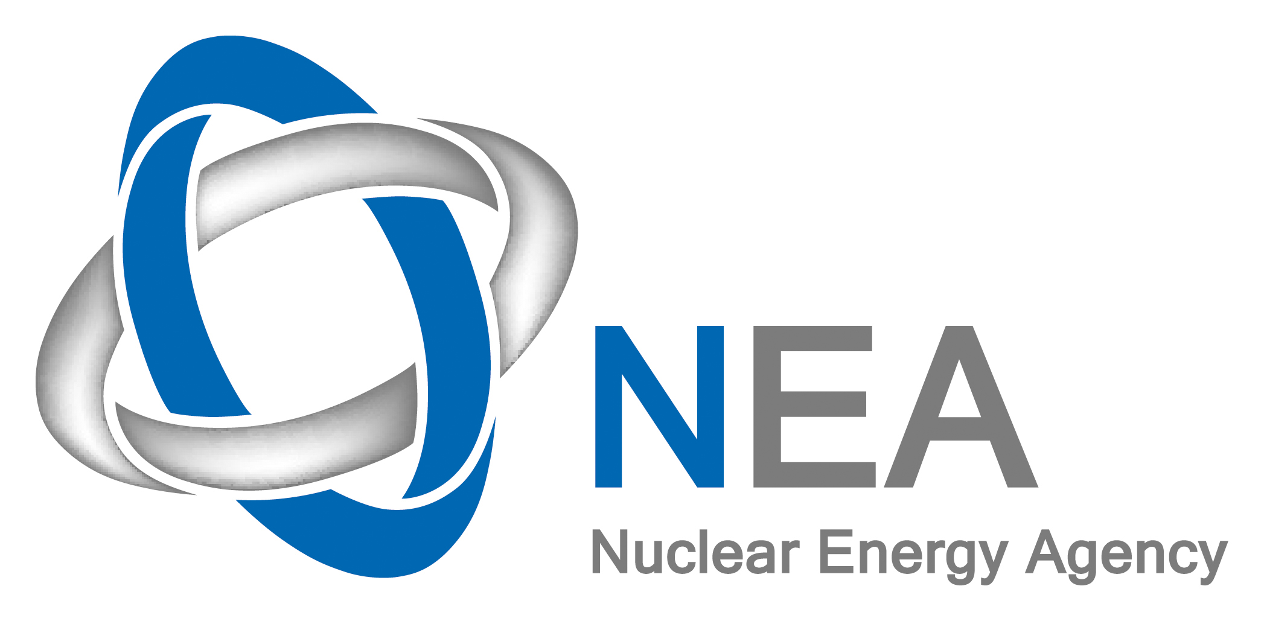

OECD Nuclear Energy Agency

International Workshop on

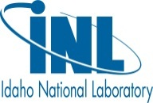

Structural Materials for
Innovative Nuclear Systems

Hosted by

Idaho National Laboratory, Idaho Falls, USA
7-10 October 2013

Programme
Monday, 7 October
9.00 | Registration
Opening session
9.30-9.45 | Welcome address from INL |  | Todd Allen
9.45-10.00 | Welcome address from NEA |  | Stéphanie Cornet  (on behalf of Thierry Dujardin)
Session I
Chair: James Marrow
10.00-10.30 | Invited talk  Industrial perspectives on material choices for advanced nuclear systems |  | Martine Blat (EDF R&D)
10.30-11.00 | Coffee break
11.00-11.30 | Invited talk  Use of user facilities for the R&D of innovative materials |  | Todd Allen (INL, USA)
 | Overview on Programs
11.30-11.55  11.55-12.25 | The new EC FP7 MatISSE project: Materials Innovations for a Safe and Sustainable nuclear in Europe  IAEA Coordinated Research Projects (CRP) supporting development of structural materials for innovative nuclear systems |  | Céline Cabet (CEA, France)  Victor Inozemtsev (IAEA)
12.30-14.00: | Lunch
Session II: Metal Alloys
Chairs: David Gandy and Victor Inozemtsev
14.00-14.30 | Invited Talk  Code qualification and material data needs for licensing |  | Davide Bernardi (ENEA, Italy)
14.30-14.55 | Generation IV and Transmutation Materials (GETMAT) Project: First assessment of results |  | Concetta Fazio (KIT, Germany)
14.55-15.20 | Materials for innovative Lead Alloy cooled Nuclear Systems- overview |  | Georg Müller (KIT, Germany)
15.20-15.45 | Development of coatings for liquid Pb corrosion protection in next Generation IV future reactors |  | Alessandro Gessi (ENEA, Italy)
15.45-16.15 | Coffee break
16.15-16.40 | The Influence of Neutron Irradiation on the Mechanical Properties of Structural Materials in LBE Environment |  | Erich STERGAR (SCK-CEN, Belgium)
16.40-17.05 | Overview of 9Cr steels properties for structural application in Sodium Fast Reactors |  | Céline Cabet (CEA, France)
17.05-17.30 | Stress Corrosion Cracking and Oxidation of Austenitic Stainless steel 316 in Supercritical Water Reactor |  | Alberto S Aez (CIEMAT, Spain)
17.30-18.00 | Discussion
19.00 (TBC) | Conference Dinner
Tuesday, 8 October 2013
8.30-15.00 | Registration
Session III: Metal Alloys
Chairs: Concetta Fazio & Richard Wright
9.00-09.25 | Nickel based alloys compatibility with fuel salts for molten salt reactor with thorium and uranium support |  | Olga Feinberg/Victor Ignatiev ( Russia Federation)
9.25-9.50 | Mechanical Properties of Ni-based superalloys in high temperature steam environments |  | Changheui Jang (KAIST, Rep. of Korea)
9.50-10.15 | Novel Experiments to Characterize Creep-Fatigue Degradation in VHTR Alloys |  | Richard Wright (INL, USA)
10.15-10.45 | Coffee break
10.45-11.10 | Fatigue and Creep Crack Propagation behaviour of Alloy 617 in the Annealed and Aged Conditions |  | Julian Benz (INL, USA)
11.10-11.35 | Evaluation of In-Situ Tritium Transport Parameters for Type 316 Stainless Steel during Irradiation |  | Walter LUSCHER (PNNL, USA)
11.35-12.00 | Microstructure Reconstruction for Phase Field Modeling of Irradiated Cladding |  | Bradley FROMM (INL, USA)
12.00-12.30 | Discussion
12.00-14:00 | Lunch
Session IV: Novel Pathways
Chairs: Céline Cabet & Ji-Yeon Park
14.00-14.25 | Powder Metallurgy and Hot Isostatic Processing for Research for Structural and Pressure Retaining Applications within the Electric Power Industry |  | David Gandy ( EPRI, USA)
14.25-14.50 | Processing of a novel nanostructured ferritic steel via spark plasma sintering and investigation of its mechanical and microstructural characteristics |  | Indrajit CHARIT (Uni. Idaho, USA)
14.50-15.15 | Development of swelling-resistant ODS and ferritic-martensitic alloys based on insights obtained using self-ion irradiation at a very high dpa rate |  | Frank Garner (DSL Extreme, USA)
15.15-15.30 | Discussion
15.30-16.00 | Coffee Break
Session 1 : Poster session on Metal Alloys & Novel Pathways
Chair: Todd Allen & Lorenzo Malerba
16.00-17.30 | Presentations on posters ( 3 mins each)
17.30-19.00 | Poster Session ( + drinks)
Wednesday, 9 October
Session V: Ceramics and Ceramic Composites
Chairs: Georg Müller + Hirotatsu Kishimoto
9.00-9.25 | Extra-Safe LWR Core with SiC/SiC Fuel Cladding by NITE Method |  | Akira Kohyama (Muroran Institute of Technology, Japan)
9.25-9.50 | Fabrication and Properties of SiC Ceramics for the Application of LWR Fuel Cladding |  | Ji-Yeon Park (KAERI, Rep. of Korea)
9.50-10.15 | Inhibition of Oxidation in Nuclear Graphite |  | Philip Winston (INL, USA)
10.15-10.45 | Coffee break
10.45-11.10 | Effect of Neutron Irradiation on Select Mn+1AXn Phases |  | Darryl Tallman (SRNL, USA)
11.10-11.35 | Helium Irradiated Ti₃AlC₂ |  | Maulik PATEL (UTK, USA)
11.35-12:00 | Potentiometric Oxygen Sensor Based on Gadolinia Doped Ceria (GDC) and Yttria Stabilized Zirconia (YSZ) for the Use in SFR Application |  | SangHun SHIN (Korea)
12.00-12.30 | Discussion
12.30-14.00 | Lunch
Session VI: Fundamentals & Ions vs. Neutrons
Chair: Frank Garner & Alessandro Gessi
14.00-14.25 | An EXAFS Study of Radiation Damage in ZrC and ZrN |  | Jeff Terry (IIT, USA)
14.25-14.50 | Overview of On-Going Studies on the Fast-Reactor Cladding Material AIM1 |  | Arnaud Courcelle (CEA, France)
14.50-15.20 | Invited talk  Perspectives on modelling materials far from equilibrium |  | Pascal Bellon (UIUC, USA)
15.20-15.35 | Discussion on session
15.35-16.00 | Coffee break
16.00-16.25 | Nanostructure evolution under irradiation and correlation with mechanical property changes in neutron irradiated Fe-Cr alloys |  | Lorenzo Malerba (SCK-CEN, Belgium)
16.25-16.50 | Ab initio based kinetic Monte-Carlo simulations of phase transformations in FeCrAl |  | Pär Olsson (KHT, Sweden)
16.50-17.00 | Discussion
Session 2: Posters on Fundamentals & Ceramics
Chairs: Grace Burke & Karl Nilsson
17.00-18.30 | Presentations on posters ( 3 mins each)
18.30-20.00 | Poster Session ( + drinks)
Thursday, 10 October
Session VII: Discussion on Ion vs. Neutron Irradiation
Chair: Stuart Maloy
9.00-9.20 | Neutron vs ion irradiation: differences and similarities in the nanostructural evolution of Fe-Cr alloys irradiated at 300°C |  | Lorenzo Malerba (SCK-CEN, Belgium)
9.20-9.40 | Ion Beams as a Quantitative Surrogate for Neutrons: is there a path forward? |  | Michael Fluss (LLNL, USA)
9.40-10.00 | Is the "temperature shift" model valid for correlation of neutron and charged particle irradiations? |  | Frank Garner (DSL Extreme, USA)
10.00-11.00 | Discussion
11.00-11.45 | Meeting Summary from the session chairs
11.45-12.30 | Open discussion  Closing speech (10 mins) |  | James Marrow (Uni. Oxford, UK)
12.30-14.00 | Lunch (provided for people on the tour)
14.00-17.00 | Technical tour – INL facilities

